UPPWISE INDIA

www.uppwise.com



**Quaterly Development Planning**

**Q1-2024**

**Feature: Execution Management - Activity Manager Role Implementation**

**Feature Title:**

Execution Management - Activity Manager Role Implementation

**Priority:**

Medium

**Submitted By:**

SPM

**Target Users:**

Standard – Customer: AXA

**Feature Description:**

This feature enhances the functionality of the Gantt editor by allowing users to assign resource to milestones when creating new tasks. It enables project managers to accurately resources and track assignment associated with specific milestones within their projects.

**Acceptance Criteria:**

Application requires the implementation of an Activity Manager role to efficiently manage activities within various projects. This role will streamline the process of assigning tasks, tracking progress, managing resources, and overseeing costs associated with each activity.

**Implementation Plan:**

**Role Creation:**

* The Activity Manager role will be created within the role management of the application.
* This role will be specifically tailored to encompass responsibilities related to activity management within projects.

**Module Integration:**

* A new option titled "Activity Manager" will be added to the module drop-down menu within the application.
* Upon selectiocan of this option, users will assume the role and responsibilities of an Activity Manager within the designated scope.

**Access Control:**

* Individual access will be granted to users assigned the Activity Manager role.
* This access will be managed through the user edit page, allowing administrators to assign or revoke the Activity Manager role as needed.
* Grant the permission of accessability withn the user which can be block for the multiple role all together but specific assigned on one go

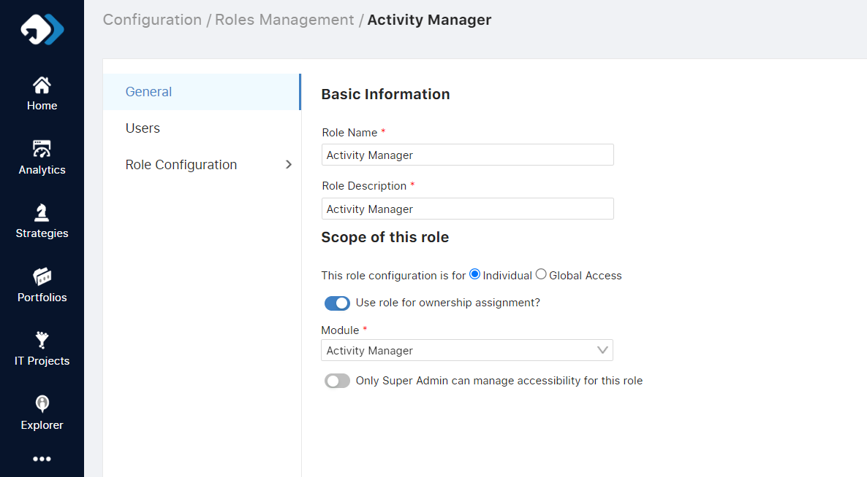

**Permission Definition:**

* The Activity Manager role will be defined with specific permissions tailored to their responsibilities.

Permissions will include:

* + Access limited to activities assigned to the Activity Manager.
  + Initiative module permission, enabling the assignment of projects.
  + Ability to edit associated activities within assigned projects.
  + Capability to add resource assignments and cost allocations to activities within projects.

**Streamlined Activity Manager Roles:**

* The introduction of the Activity Manager role will streamline the process of managing activities within projects.
* Clear ownership and responsibility will enhance accountability and efficiency in task execution.
* Activity Managers will have the authority to assign resources and allocate costs, leading to better resource utilization and cost management within projects.
* With access to edit activities and allocate resources, Activity Managers will have a comprehensive view of project progress and can proactively address any issues that arise.
* By defining specific permissions for the Activity Manager role, administrators can ensure that users only have access to relevant functionalities, maintaining data integrity and security.